CO2020 – Computer Aided Numerical Methods II
HomeWork 4 – Elliptic Equations
Report
Ishaan Jain
CO21BTECH1006

1.
The plots for T calculated by Gauss Seidel and its exact solution are as follows:
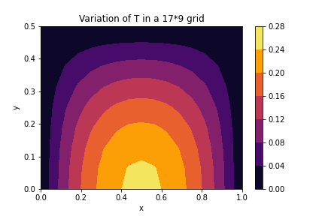
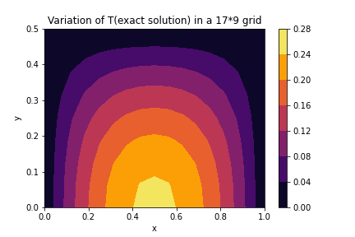
(a) 17*9 grid

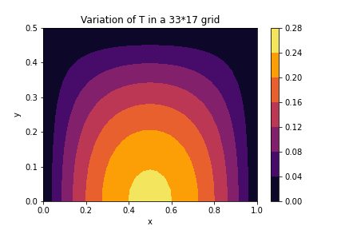
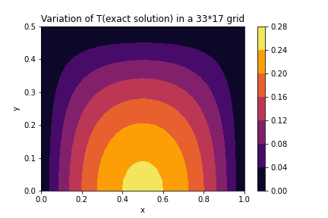
(b) 33*17 grid

The error(difference in T calculated by Gauss Seidel and exact solution) varies with the number of grid points as:
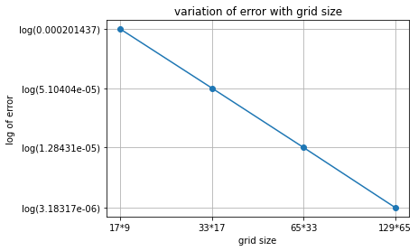
The slope of this graph is -2 (as the scheme we used is second order accurate, the error reduces 4 times when the grid size is doubled).

